**Pan-Fried Three Mushroom Dumplings**

Ingredients: (to make 20 dumplings)

* 1 packet dumpling wrappers – buy round-shaped wrappers labelled ‘gau gee’/’gow gee’/’jiaozi’, rather than wonton wrappers

* 8 dried shiitake mushrooms (about 3 cm diameter), rehydrated for 30 mins in boiled water from the kettle and finely diced

* 150g / 1 packet buna shimeji (brown beech) mushrooms, finely chopped (or any other type that you can find)

* 150g oyster mushrooms (or any other type that you can find)

* 1 tablespoon Chinese chives, finely chopped

* 1 spring onion or scallion, finely chopped

* 1 clove of garlic, finely chopped

* 1/2 teaspoon ginger, finely chopped

* 1/2 tablespoon light soy sauce

* 1/2 tablespoon Shaohsing cooking wine (optional, or use dry sherry)

* couple of twists freshly ground black pepper

* 2 tablespoons groundnut oil

[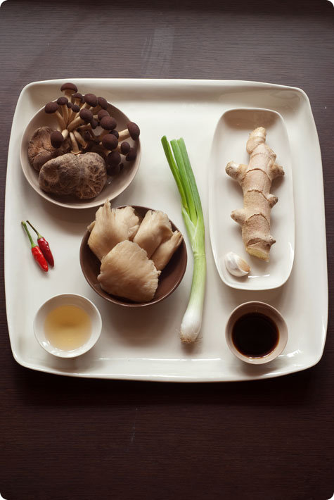](http://www.designsponge.com/2009/09/in-the-kitchen-with-helen-yuet-ling-pang.html/mushroom-dumplings-01)

Dipping Sauce:

* half a fresh red chilli, finely chopped

* 1 teaspoon freshly grated ginger

* 2 tablespoons light soy sauce

* 1 tablespoon rice vinegar

**Method:**

Keep the dumpling wrappers sealed in the packet until you are ready to fill and wrap the dumplings, otherwise they will dry out.

Prepare the dipping sauce before making the dumplings. De-seed and finely chop the red chilli and grate the ginger. Mix the ingredients together and add to a small dish.

Rehydrate the shiitake mushrooms in freshly boiled water for about 30 minutes or until soft (but not flabby), remove any tough stalks and finely dice. Cut the base off the buna shimeji and finely chop, along with the oyster mushrooms. Finely chop Chinese chives, spring onion, garlic and ginger.

Heat 1 tablespoon of groundnut oil in a wok or large non-stick frying pan on a high heat. Fry garlic and ginger for one minute, then add the chopped mushrooms, followed by soy sauce, Shaohsing wine and pepper. Stir well to ensure nothing burns. The mushrooms will cook quickly, so two minutes should be enough. At this point, add the Chinese chives and spring onions and quickly stir again. Remove from heat and transfer to a large bowl.

Lightly dab a large plate with a little cooking oil, to prevent the dumplings from sticking to it and prepare a slightly dampened tea towel to cover the dumplings you have just wrapped.

Moisten the edge of a wrapper with a dab of water. Then place some filling onto the centre, leaving enough space around the edge to seal the wrapper. Fold the wrapper in half and press together to form a half moon shape. Seal tight so that there are no gaps. Pinch and pleat just one side of the wrapper, using your right thumb (if right-handed) to support the other side that will stay smooth. There are many different ways to pleat a dumpling and it will come with practice. Don’t rush this part, as the wrapper is delicate and will tear. If you’re not confident with pleating, the half moon shape is perfectly acceptable! The important part is to seal the wrapper tight to prevent leakage.

[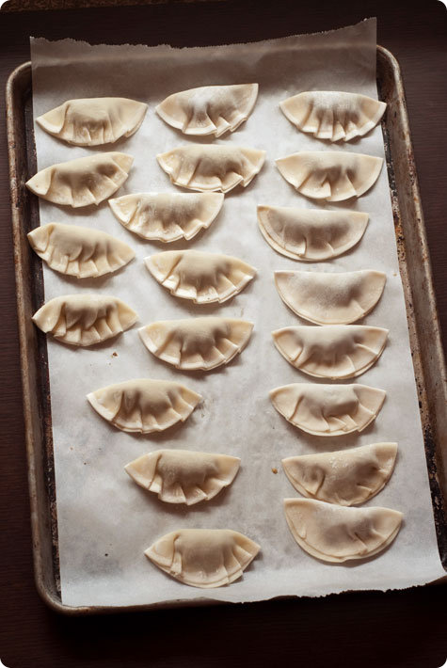](http://www.designsponge.com/2009/09/in-the-kitchen-with-helen-yuet-ling-pang.html/mushroom-dumplings-04)

Heat 1 tablespoon of groundnut oil in a large frying-pan (with a fitted lid) on a medium heat. Before it starts to smoke, add the dumplings flat side down and leave them for about a minute or until they are golden brown. You only need to fry them on one side. Then pour in a quarter of a cup of boiling water. As this will give off a lot of steam, use the lid as a shield to protect yourself and cover the pan immediately to trap the steam. Keep the lid on firmly for 3 minutes, with the heat turned down, until the moisture has evaporated. The dumplings will be fried on the bottom and steamed on the top. Serve immediately with dipping sauce.